Date:

Dear Healthcare Provider:

(staff person name) works at , a congregate care facility that includes residents that are at higher risk for more severe COVID- 19 disease. COVID-19 has not yet been confirmed in this facility.

This person has notified the facility that they have symptoms possibly consistent with COVID- 19 illness. These symptoms may include fever, cough, myalgia or fatigue, and shortness of breath. Less common symptoms include sore throat, headache and diarrhea.

If, in your clinical assessment, you determine this patient’s symptoms are consistent with COVID-19 like illness, please prioritize them for COVID-19 testing as we need to ensure timely identification of COVID-19 exposure in the facility.

To ensure timely testing, please order testing by:
- Sending a specimen(s) to a reference lab that can return results within 1-3 days. You may want to confirm turnaround time with the lab prior to sending the specimen.
- If the you do not have access to a lab that can provide timely results, you may collect a nasopharyngeal specimen and send it to the Oregon State Public Health Laboratory (OSPHL), which is currently processing specimens within one to three days which may be faster than some other laboratories.

Request for approval for testing at OSPHL must be submitted using the Confidential Oregon
Morbidity Report at w ww.healthoregon.org/howtoreport. The healthcare provider ordering
the test must be sure to answer “Yes” to “Does the patient work or live in a congregate setting (e.g., LTCF, correctional facility, shelter)” question on the report form.

If you choose to send the specimen to OSPHL, please follow OSPHL specimen acceptance
criteria posted on the OSPHL Lab Test Menu at w ww.healthoregon.org/labtests.

If you have specific clinical questions about COVID-19, please call the clinician consultation line at 971-673-1111 and select 1 and then 3.

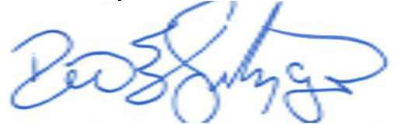
Thank you for assistance. Sincerely,

Dean Sidelinger, MD, MSEd, FAAP
State Health Officer (Facility Person In Charge)

Phone Number

